**Prasanna Dhungana**

**21053439**

**A-28**

**LAB Assignment 12**

**1. Write a C Program that passes three variables (a, b, c) as separate**

**parameters to another user-defined function and rotates the values stored**

**so the value of ‘a’ goes to ‘b’, value of ‘b’ goes to ‘c’, and value of ‘c’ to ‘a’.**

***Program:-***

**#include<stdio.h>**

**void swap(int *, int *, int *);**

**int main(){**

**int a , b , c ;**

**printf("\n\nEnter the three numbers to swap :");**

**scanf("%d %d %d", &a , &b , &c);**

**printf("Before Swap:\n");**

**printf("a = %d , b = %d , c = %d\n\n ",a,b,c);**

**swap(&a , &b , &c);**

**printf("After Swap:\n");**

**printf("a = %d , b = %d , c = %d\n\n ",a,b,c);**

**return 0;**

**}**

**void swap(int *x, int *y, int *z){**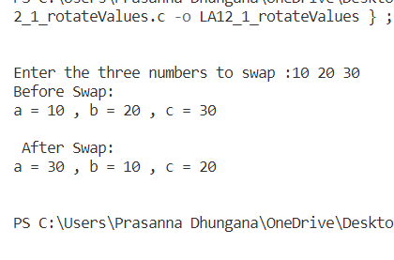

**int temp;**

**temp = *x;**

**\*x = *z;**

**\*z =*y;**

**\*y = temp;**

**}**

***Output:-***

**2. Write a C Program that passes the values of variables a, m to a function**

**power() that finds the value of a m inside its body and saves the value to**

**result variable implicitly.**

***Program:-***

**#include<stdio.h>**

**void power(float , int , float *);**

**int main(){**

**int m ;**

**float a , result;**

**printf("\n\nEnter the value of integer and the power to which it will be raised :");**

**scanf("%f %d",&a , &m);**

**power(a , m , &result);**

**printf("The result is : %.3f\n\n",result);**

**return 0;**

**}**

**void power( float x , int y , float *r){**

**int i;**

**\*r = 1.0;**

**for (i = 0; i<y ; i++){**

**\*r *= x;**

**}**

**}**

***Output:-***

